Version 1.0

Revision History

|  |  |  |  |
| --- | --- | --- | --- |
| **Date** | **Version** | **Description** | **Author** |
| 10/12/2019 | 1.0 | details | Pham Thi Hong Trang |
|  |  |  |  |
|  |  |  |  |
|  |  |  |  |

Table of Contents

1. Introduction 4

1.1 Purpose 4

1.2 Scope 4

1.3 Definitions, Acronyms, and Abbreviations 4

1.4 References 4

1.5 Overview 4

2. Business Use-Case Name 4

2.1 Brief Description 4

3. Goals 4

4. Performance Goals 4

4.1 <name of performance goal> 5

5. Workflow 5

5.1 Basic Workflow 5

5.1.1 <name of workflow step> 5

5.2 Alternative Workflows: Still achieve success but in different way 5

5.2.1 <name of workflow step> 5

6. Risk 5

7. Possibilities 5

8. Process Owner 5

9. Special Requirements 5

9.1 <Name of Special Requirement 1> 5

9.2 <Name of Special Requirement 2> 5

10. Extension Points 6

10.1 <Name of Extension Point> 6

Business Use-Case Specification: Manage Customer Feedback

# Introduction

## Purpose

The purpose of this business use-case is to show how to manage customer feedback of the computer shop when manager deal with problems happens related feedback.

## Scope

The scope of this business use-case is associated with the computer shop to be deployed

## Definitions, Acronyms, and Abbreviations

Manager: Admin.

## References

TBD.

## Overview

The rest of the Business Use-case Specification contains goal, risk, process owner and special requirement.

# Business Use-Case Name

## Brief Description

The use-case here is that “Manage Customer Feedback”, which means the managers have to deal with all problems related to feedback of customer.

# Goals

In this use-case, manager have only one main task: view feedback in detail, delete feedback.

# Performance Goals

## Manager Can Delete Feedback

When customer send a feedback to computer shop, manager will check it and delete impolite feedback.

# Workflow

A customer bought computer from CT store, and send feedback about the quality of computer, services of computer shop. But in special situation, some customer uses impolite comments. That effects seriously to computer shop and admin can detect immediately by clicking in manage customer feedback, view it in detail and delete it getting out computer shop system to ensure about the shopping environment.

## Basic Workflow

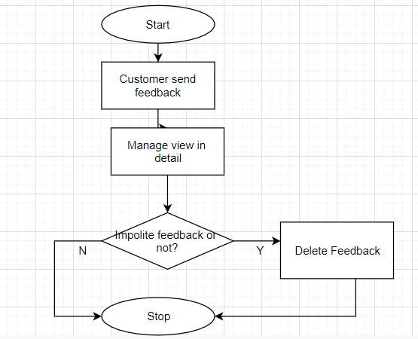

# Risk

No special.

# Possibilities

No special.

# Process Owner

The process owner if this usecase is the administrator or can be called manager of the computer shop who deal with the situation.

# Special Requirements

No special.

# Extension Points

No extension points.